**Equation and Inequalities**

Solve $7x+18=74$

$$x=_____________________________$$

Solve $\frac{2y}{5}-6=4$

$$y=_____________________________$$

Solve $13x+1=11x+9$

$$x=_____________________________$$

Solve $4\left(5y-2\right)=48$

$$y=_____________________________$$

Write an equation for this statement:

A number divided by 2, plus 5, is 8.

_______________________

Solve $4\left(6x-7)-(3x-5\right)=40$

Show your work

$$x=_____________________________$$

An equipment rental company charges a flat rate of $25, plus $13 per day for insurance. Kyle has $121. Write an inequality to represent the number of days, d, for which he can rent equipment.

_______________________

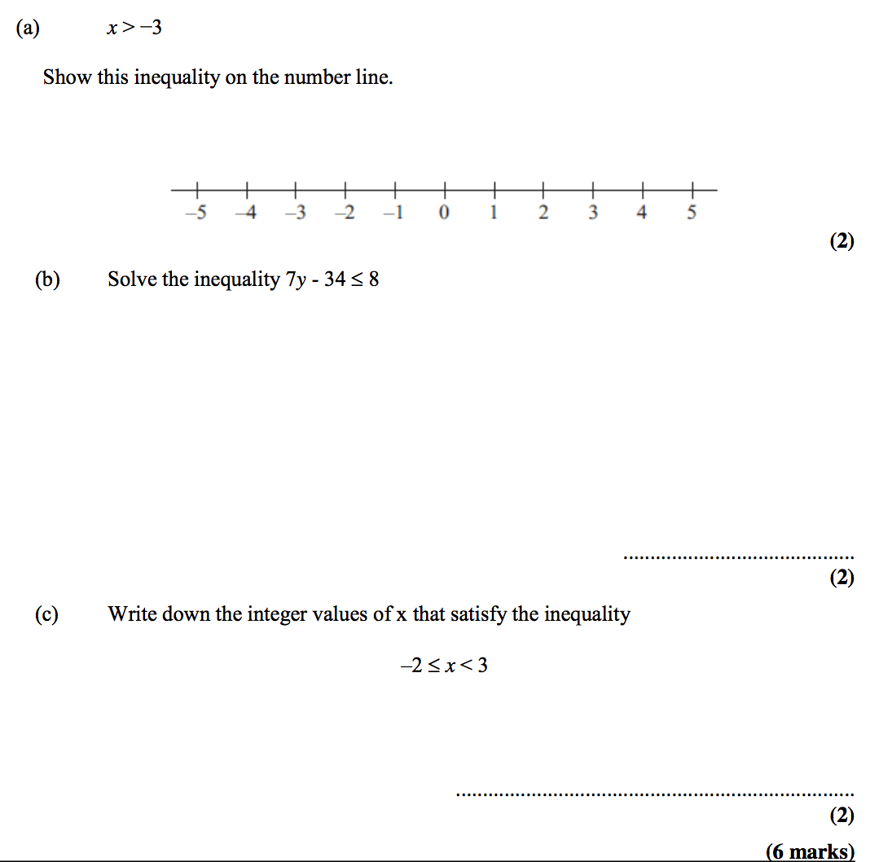

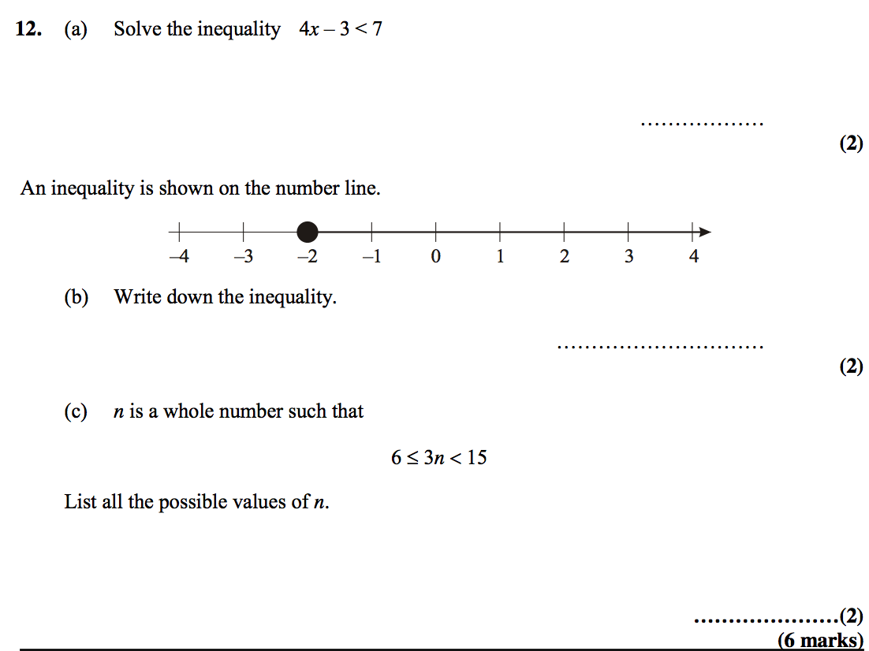

Solve $\frac{2}{3}\left(x+2\right)-\frac{1}{2}\left(x-4\right)>\frac{1}{4}(x+5)$

Show your work

$$x=_____________________________$$